**A PROPOSED OFFERING OF A GYM MANAGEMENT**

**SYSTEM FOR ANYTIME FITNESS GYM**

A Requirement Specification Document Presented to the

Faculty of Datamex College of Saint Adeline, Inc.

In Partial Fulfillment of the Requirements for the

Degree of Bachelor of Science in Information Technology

By:

Revilla, James Andrei N.

**INTRODUCTION**

The purpose of this document is to clearly define the detailed requirements for the Gym Management System (GMS) under development. This requirements specification aims to serve as the foundational guideline for the design, development, testing, and deployment phases. It formalizes what the system must achieve to meet the business goals and user needs, providing a reference to ensure all stakeholders share a common understanding of the software capabilities and constraints.

This document is intended for a wide audience including project managers, developers, testers, system architects, and client representatives. It facilitates communication among translators, reduces ambiguities, and supports project planning activities such as task estimation, resource allocation, and quality assurance.

The Gym Management System is a comprehensive software solution designed for administrative staff at fitness centers to manage member registrations, attendance monitoring, equipment inventory, payments, and user accounts. The system aims to replace cumbersome manual processes with automated workflows to enhance operational efficiency and data accuracy.

Developed as a Windows desktop application interfacing with a Microsoft SQL Server database backend, GMS supports secure user authentication including password hashing and two-factor authentication to safeguard sensitive information. The software provides various modules such as member and equipment management, attendance tracking, payment processing, and an administrative dashboard summarizing key statistics.

Users of this system primarily include gym staff responsible for day-to-day management, trainers needing attendance and member status insights, and administrators overseeing staff accounts and financial transactions.

This specification covers both functional and non-functional requirements that define the behaviors and quality attributes expected from the Gym Management System. It includes detailed descriptions of all major system functionalities, such as member registration, payment verification, attendance handling, equipment lifecycle management, and reporting features.

Constraints such as supported platforms (Windows desktop), third-party dependencies, and security policies are documented. Requirements related to performance, reliability, usability, scalability, security, and maintainability are included to ensure the system operates effectively in the intended environment.

Requirements falling outside this scope, such as mobile or web versions, external marketing tools, or integrations not yet approved, will be managed separately as future enhancements or different projects.

**FUNCTIONAL REQUIREMENTS**

This section outlines the specific features that the Gym Management System must deliver to support its intended operations. Each requirement is documented with a unique identifier, description, and assigned priority to ensure clarity and proper tracking. Dependencies between requirements are highlighted to show relationships and implementation order. Clear acceptance criteria are defined for each requirement, providing measurable conditions to verify that the functionality is complete and meets user expectations.

Each functional requirement below is uniquely identified to enable precise tracking and traceability throughout the project lifecycle.

**Staff Authentication**

* **Requirement ID:** FR-001
* **Description:** The system shall provide secure login and registration for gym staff. Credentials shall include a username, a password stored as a hashed value, and a security question answer for recovery purposes. Two-factor authentication (2FA) must be implemented to add an extra layer of account protection.
* **Priority:** High
* **Dependencies:** None
* **Acceptance Criteria:** Staff can register and log in using a unique username and password. Upon registration, a 2FA setup is enforced. Login attempts without correct 2FA are denied. Password reset functionality requires answering the security question correctly before allowing password update.

**Member Registration**

* **Requirement ID**: FR-002
* **Description:** Authorized staff shall be able to register new gym members by entering personal details and membership plan information. The system shall validate that the initial down payment is processed before activating the membership and generating a unique membership ID.
* **Priority:** High
* **Dependencies:** FR-001 (Staff must be authenticated to register members)
* **Acceptance Criteria:** The "Add Member" form accepts and stores all relevant member data. Payment validation is mandatory. Members who have not completed payment remain inactive. Each new member is assigned an automatically generated membership ID upon activation.

**Attendance Tracking**

* **Requirement ID:** FR-003
* **Description:** The system must allow staff to check members in and out of the gym, capturing timestamps and associating them with member records. It shall also provide attendance history views with search capability.
* **Priority:** High
* **Dependencies:** FR-002 (Members must exist before attendance can be recorded)
* **Acceptance Criteria:** Attendance check-ins and check-outs are recorded with accurate timestamps. Attendance records related to members are searchable by date, member ID, or name. Reports summarizing daily or monthly attendance are generated upon request.

**Equipment Management**

* **Requirement ID:** FR-004
* **Description:** Staff shall be able to add, edit, view, and delete gym equipment records, including maintenance dates and current operational status.
* **Priority:** Medium
* **Dependencies:** FR-001 (Only authenticated staff can manage equipment)
* **Acceptance Criteria:** Equipment information can be accessed and modified through a user-friendly interface. Maintenance schedules can be added and flagged for alerts.

**Payment Processing**

* **Requirement ID:** FR-005
* **Description:** The system shall support member payment processing to update balances and membership status. Payment data must be recorded securely and linked to member accounts.
* **Priority:** High
* **Dependencies:** FR-002
* **Acceptance Criteria:** Payments are successfully recorded and balances updated. Accounts reflect current payment status. Payment receipts are available for print or export.

**NON-FUNCTIONAL REQUIREMENTS**

Beyond functionality, the Gym Management System must meet key quality standards. These non-functional requirements address system attributes critical to performance, user satisfaction, and long-term viability.

**Performance**

The system must respond to user actions within two seconds under normal operating conditions. Bulk operations such as member searches or report generation should complete in under five seconds. The application must handle concurrent access by at least 20 staff members without noticeable degradation.

**Usability**

The GUI shall follow modern design principles with clear navigation and consistent element placement. The system must support accessibility features such as keyboard navigation and screen reader compatibility for users with disabilities. Error messages should clearly describe problems and actions to resolve them.

**Reliability**

The system shall maintain 99.9% uptime during business hours. Automatic backup routines will run nightly to prevent data loss. Failures during critical operations should trigger rollback mechanisms to preserve data integrity.

**Security**

All sensitive data shall be encrypted at rest and in transit. User passwords are hashed with salts using industry-standard algorithms. Role-based access control mandates that users only access features according to their permissions. Two-factor authentication is mandatory for all staff logins.

**Scalability**

The design must allow future increases in user counts and data volumes without significant architectural changes. The system will support database optimizations and modular code to facilitate scalability.

**Maintainability**

The codebase shall follow established design patterns with modular components and clear interfaces to ease updates and bug fixes. Comprehensive logging and documentation must be provided to support maintenance and auditing.

**USE CASES**

The use cases define the core interactions between staff and the Gym Management System, focusing on authentication, member registration, and attendance management. Each use case specifies the necessary conditions, actors, and outcomes, ensuring that the system supports essential workflows while addressing potential exceptions. These use cases guide the system’s design by outlining real-world scenarios and expected responses, ensuring both functionality and reliability.

**Staff Login**

* **Use Case ID**: UC-001
* **Use Case Name:** Staff Login
* **Description:** Staff members enter credentials, including username, password, and 2FA code, to gain access. The system authenticates inputs and redirects authenticated users to the dashboard.
* **Actors:** Staff (User)
* **Preconditions:** Staff has valid registration and credentials.
* **Postconditions:** User is logged into the system with an active session.
* **Alternate Flows:** Incorrect password or 2FA failure leads to an error message and reattempt.

**Add New Member**

* **Use Case ID:** UC-002
* **Use Case Name:** Member Registration
* **Description:** Staff fills out member details in the registration form. The system validates the data, and after down payment confirmation, creates the member record with membership ID generated.
* **Actors:** Staff
* **Preconditions:** Staff must be logged in. Payment system is operational.
* **Postconditions:** Member is added and activated. Membership ID issued.
* **Alternate Flows:** Payment not verified; member status remains inactive.

**Check-In Member**

* **Use Case ID:** UC-00
* **Use Case Name:** Member Check-In
* **Description:** Staff records a member’s entry by selecting their membership and confirming check-in. A timestamp is associated.
* **Actors:** Staff
* **Preconditions:** Member exists and is active.
* **Postconditions:** Attendance record updated.
* **Alternate Flows:** Member not found or membership expired; check-in denied.

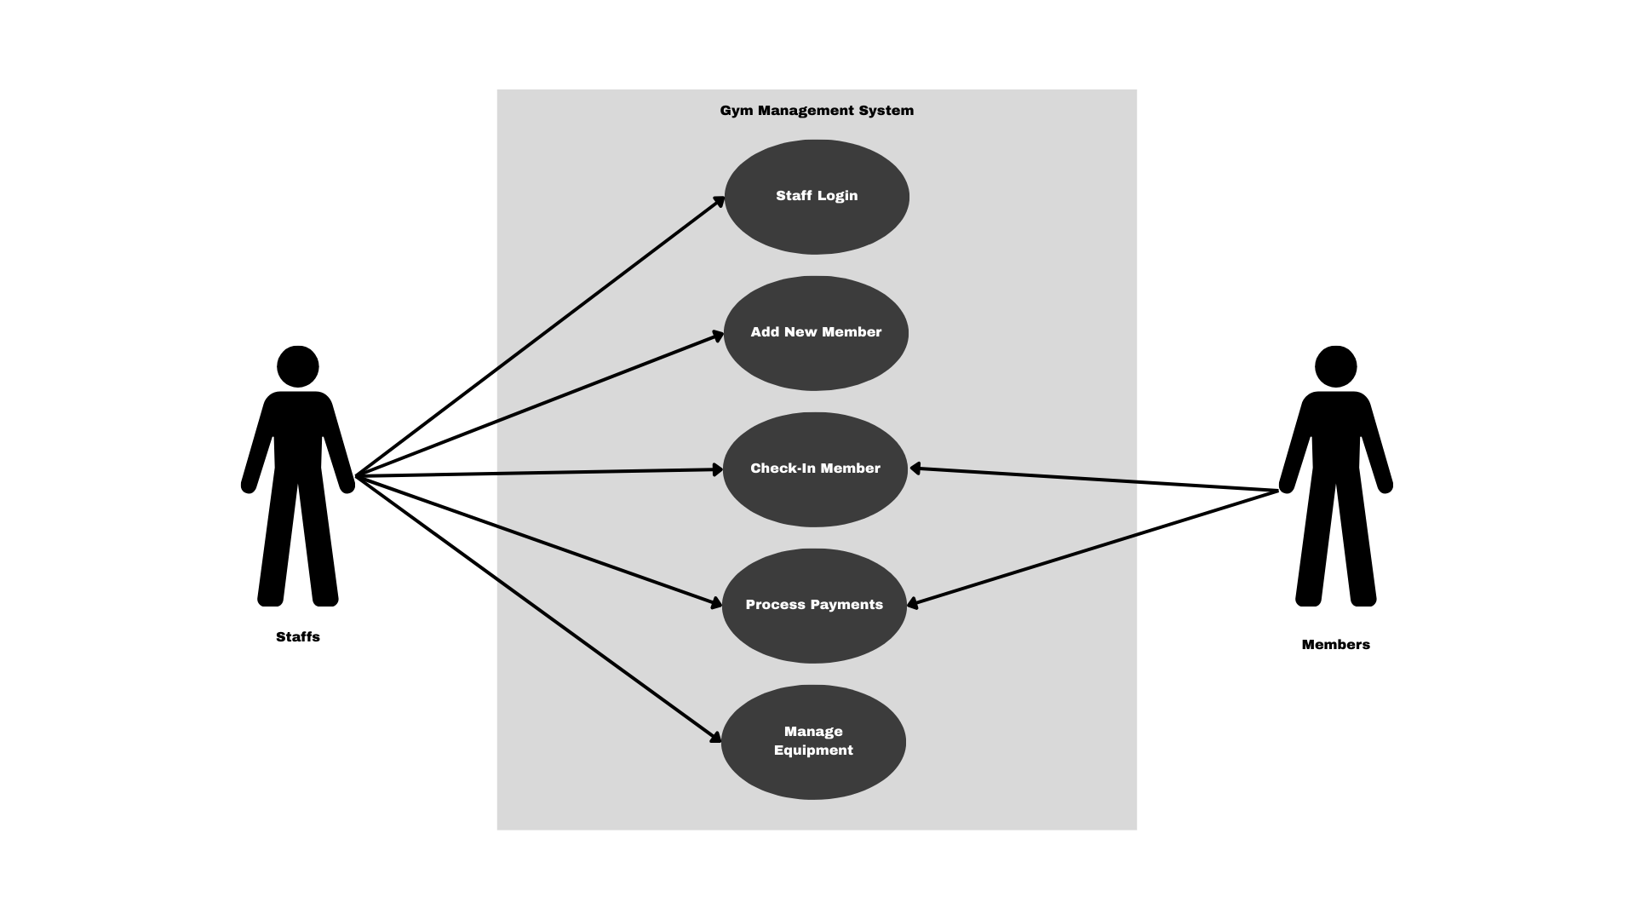

**Figure 1.** Use Case**DATA REQUIREMENTS**

The Gym Management System manages all essential data using three core database tables: Users, Gym Equipment, and Members. This simplified data model consolidates related information for better efficiency while maintaining clear entity boundaries.

**Users Table**

The Users table stores authentication and security information for gym staff and administrators who access the system. It includes the following columns:

* **id:** A unique numeric identifier assigned to each user. This serves as the primary key.
* **username:** The staff member’s login name, required for authentication.
* **password:** The securely hashed password associated with the username, ensuring credentials are not stored in plaintext.
* **secQuestion:** A predefined security question used for account recovery purposes.
* **secAnswer:** The hashed or encrypted answer to the security question, providing an additional security layer.
* **Status:** Indicates the current status of the user account managing access control.

This centralized table governs all user authentication, password recovery, and access management functions, forming the foundation of system security.

**Gym Equipment Table**

The Gym Equipment table maintains detailed records of all physical assets owned by the gym. Its columns include:

* **idequipment**: Unique identifier for each piece of equipment.
* **Name**: The common or brand name of the equipment.
* **description**: A textual description that may include specifications, condition, or usage notes.
* **PurchaseDate**: The date the equipment was acquired by the gym, useful for warranty and depreciation tracking.
* **Quantity**: The number of identical pieces of this equipment currently available.
* **Vendor**: The supplier or manufacturer of the equipment.
* **ContactNum**: Contact information for the vendor, facilitating maintenance or replacement inquiries.
* **CostperItem**: The purchase cost for a single unit of the equipment.

By managing equipment data comprehensively in this table, the system supports inventory management, maintenance scheduling, and cost tracking.

**Members Table**

The Members table consolidates member personal information, subscription data, payment details, membership status, and attendance count into a single comprehensive record per member. The attributes are:

* **member_id:** Unique identifier for each member.
* **fullname:** The full name of the member.
* **email:** The member’s email address for communication.
* **contact_num:** Phone or mobile contact number.
* **birthdate:** Date of birth for demographic data and eligibility checks.
* **Address:** Residential or mailing address.
* **DOR (Date of Registration):** The date the member joined the gym.
* **servicesplan:** Indicates the membership or service plan chosen by the member
* **amount:** The total payment amount related to the membership plan.
* balance: The outstanding balance on the member’s account, reflecting unpaid dues.
* **member_status:** Defines whether the member is active, expired, suspended, or pending.
* **attendance_count:** A summarized count of total attendance records logged for the member, useful for usage metrics and reporting.

This comprehensive member table simplifies queries and reports by integrating both static profile data and dynamic financial and attendance information. It supports member management, payment tracking, status validation, and attendance-based analytics without requiring multiple tables joins.

**Data Relationships and Integrity**

In this simplified schema, relationships are primarily managed at the application level due to consolidation. For instance, the member_id serves as the key reference to identify a member uniquely in all operations including payments, status updates, and attendance tracking (attendance is maintained as an attendance count here; detailed records are presumed to be part of member-related transactions or logged separately if required).

Similarly, the Users table functions autonomously, managing authentication, while the Gym Equipment table stands independently for inventory control. Data integrity constraints such as unique keys, not-null requirements, and indexed lookup fields ensure efficient retrieval and consistency. Security measures such as encryption and hashing on sensitive fields prevent unauthorized access and protect user data.

**ASSUMPTION AND CONSTRAINS**

This section identifies the foundational assumptions made during the development of the Gym Management System, as well as the constraints that may impact its design, implementation, and deployment. Assumptions reflect conditions believed to be true for project success, such as availability of internet connectivity or consistent user access to supported devices. Constraints define limitations such as budget, time, technology stack, or regulatory compliance requirements that restrict solution options. Recognizing these factors early helps ensure realistic planning and risk mitigation throughout the development lifecycle.

**Assumptions and Constraints**

To ensure clarity in project planning and execution, certain assumptions are made about the resources, environment, and user capabilities, while recognizing specific constraints that may limit the system’s development and functionality. Identifying these factors early helps guide realistic expectations for the final product.

**Assumptions**

* Users will have basic computer literacy to operate the system.
* The gym will provide a computer with Windows OS compatible with Visual Basic
* All necessary data for testing and demonstration will be provided in advance.
* Internet connection is not required for core system functions.

**Constraints**

* Development is limited to Visual Basic 2010 and local database storage due to available resources.
* The system will run only on Windows-based machines.
* Timeframe and budget restrictions limit advanced features like online payment integration or mobile app development.
* All functionalities must operate in an offline environment without reliance on external APIs or services.

**GLOSSARY**

This section provides definitions of key terms used within the Gym Management System. It ensures clarity and consistency by explaining important concepts related to membership, payments, attendance tracking, and security. These definitions serve as a reference for both system users and developers to maintain a shared understanding of terminology.

**Membership ID -** A unique identifier generated for each registered member.

**Down Payment -** An initial payment made by prospective members to activate membership.

**Check-In/Check-Out -** Process of recording member presence at gym entry and exit.

**Role-Based Access Control (RBAC) -** Security model restricting system access based on user roles.

**Two-Factor Authentication (2FA) -** Security process requiring two proofs of identity before granting access.

**REVISION HISTORY**

This section documents all changes made to the Gym Management System’s design, requirements, and documentation throughout the project lifecycle. Each revision entry includes a unique version number, the date of the change, the author or team responsible, and a brief description of the modifications.

|  |  |  |  |
| --- | --- | --- | --- |
| **Date** | **Version** | **Description** | **Author** |
| 2025-08-26 | 1.0 | Initial Document Creation | Revilla, James Andrei N. |

**Table 1.** Revision History